|  |  |  |  |  |  |
| --- | --- | --- | --- | --- | --- |
| Date | 1-Dec-22 | | | Tester Name | Richard Belanger |
| Environment | Penfax - Test | | | Login used | TEST2 |
| Operating System | Windows | Version: | Update: | | |
| Software Used | Edge | Version: | Update: | | |
| Not Applicable | Version: | Update: | | |
| Release version | 22.4.1 | | | | |
| Title | M8.12 General 12 month married member eligible for reduced pension and different service type | | | | |
| Test Type | Regression | | | | |
| Test Scenario | Terminate member for the purposes of Retirement | | | | |
|  |  | | | | |
| Expected Results | The member will be terminated and placed on Pension | | | | |
| Pass/Fail | Pass | | | JIRA# | N/A |

Describe your steps with screenshots:

Member is 12 Month and Eligible for a Reduced Pension

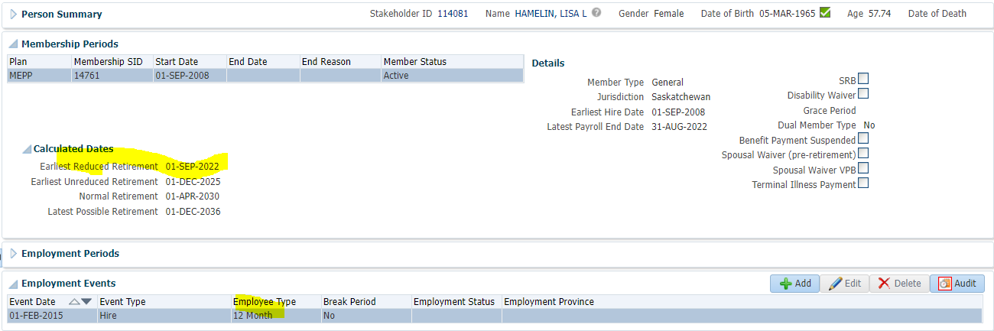

Terminate member for purposes of retirement

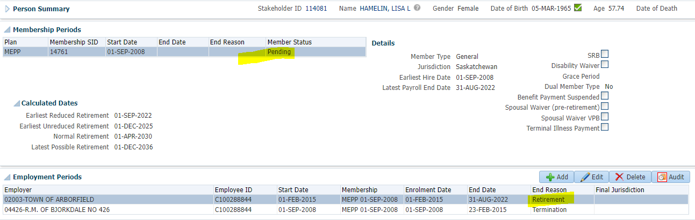

To Benefit Calculation>Calculate

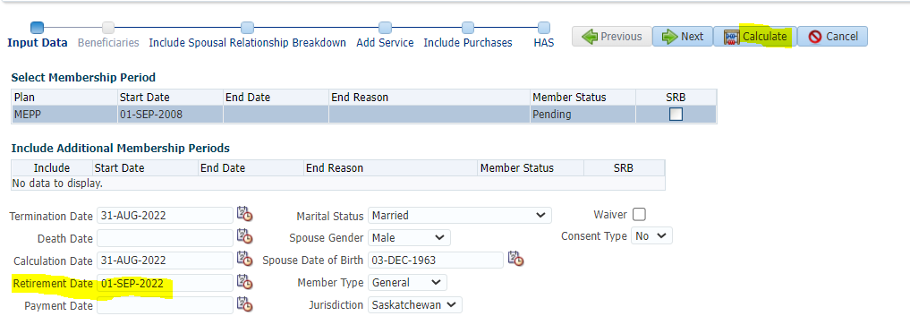

Process

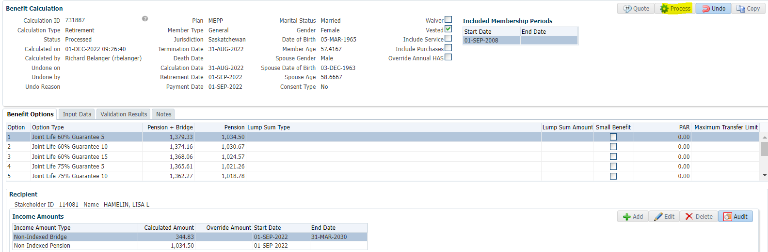

To Benefit Selection>Next

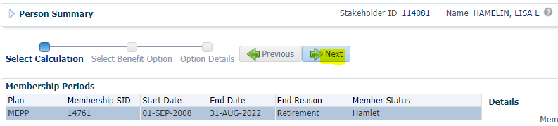

Next

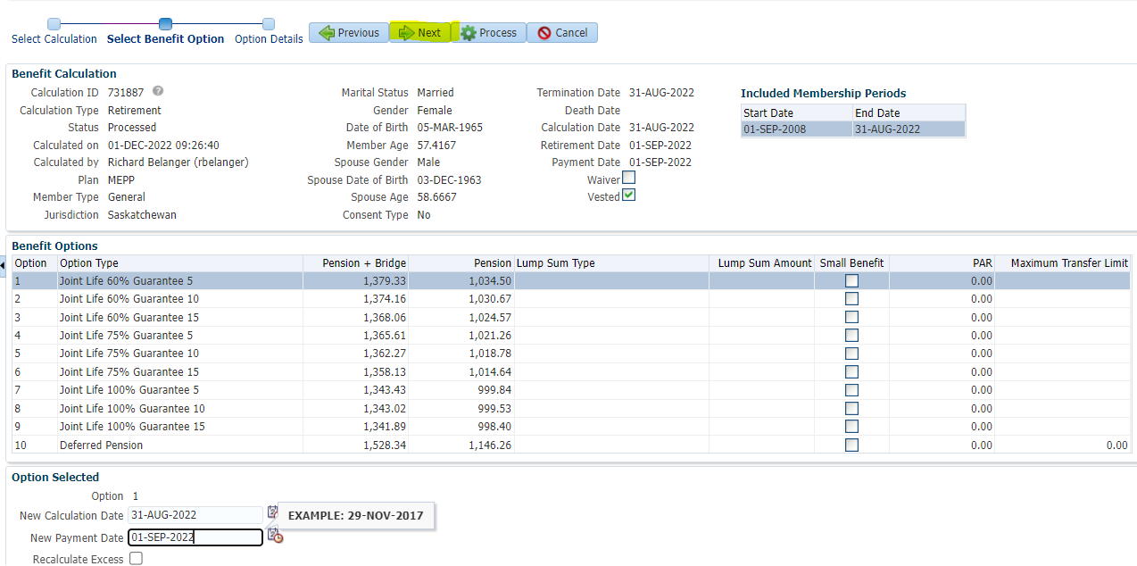

Payment Instructions added; Tax Instructions added>Process

Member is Pensioned

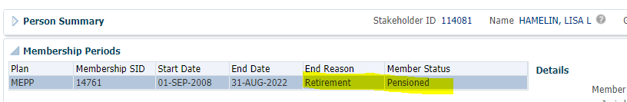

To Benefit Recipient

Income Benefit

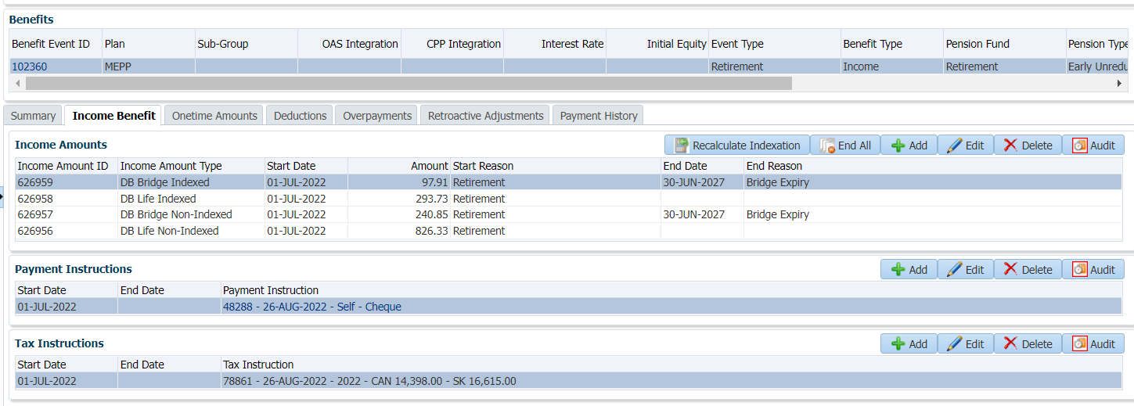

To Summary to Authorize>Authorized

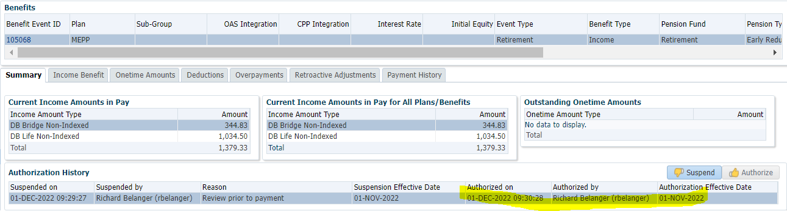

Retroactive Payment for September/October/November 2022

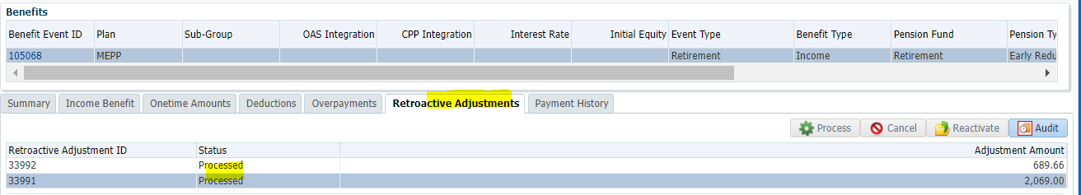

Retro Payment History with Income Tax taken

